Windows Operating System Enumeration Activity:
You have been assigned a Windows 10/11 system in the laboratory environment. Perform 5machine. Collect and document the operating system version, hostname, local user accounts, running services, network configuration, and installed software using appropriate Windows commands and PowerShell utilities. Record screenshots of the commands executed and their outputs. Analyze the collected information and prepare a brief report explaining how system enumeration helps administrators understand system configurations, manage assets, troubleshoot issues, and identify potential security risks in an authorized environment.

Aim:
To enumerate a Windows 10/11 operating system and collect system information using built-in Windows commands.
Commands Used:
- systeminfo
- hostname
- net user
- sc query
- ipconfig /all
- Get-Service
- Get-ItemProperty
- whoami
- netstat -ano
Procedure
- Open Command Prompt as Administrator.
- Execute each command one by one.
- Save the screenshots for your report.
Result:

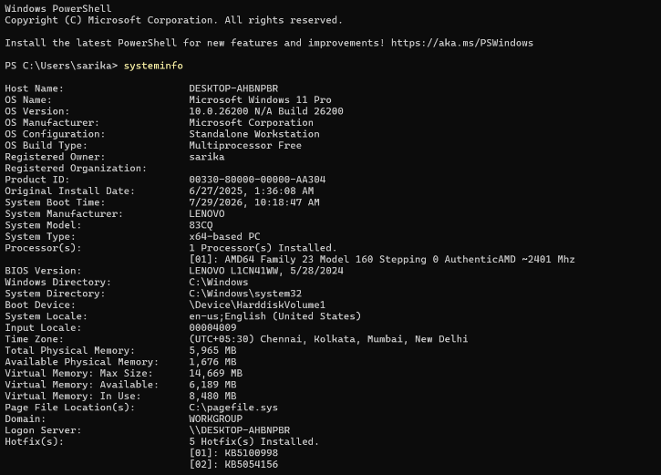

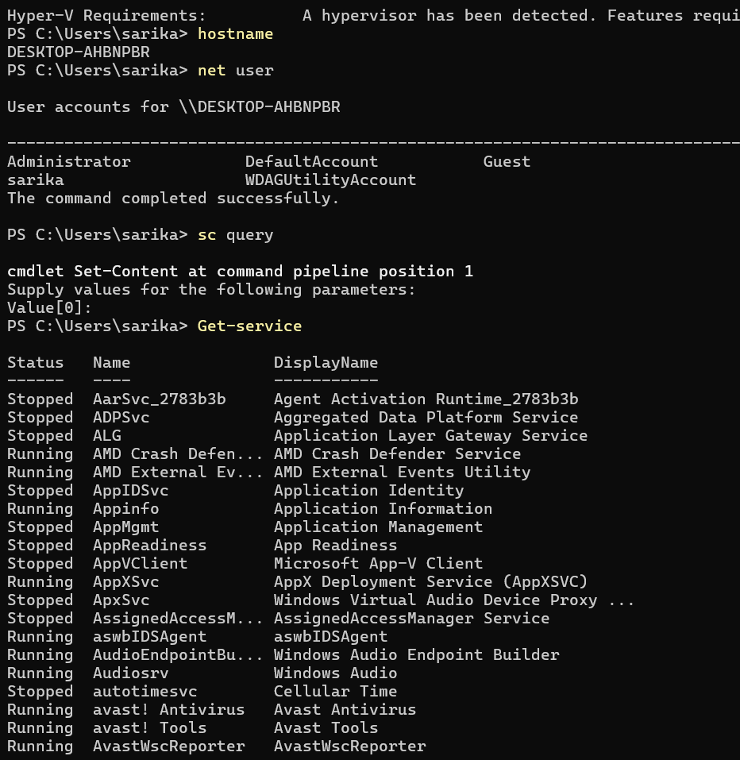
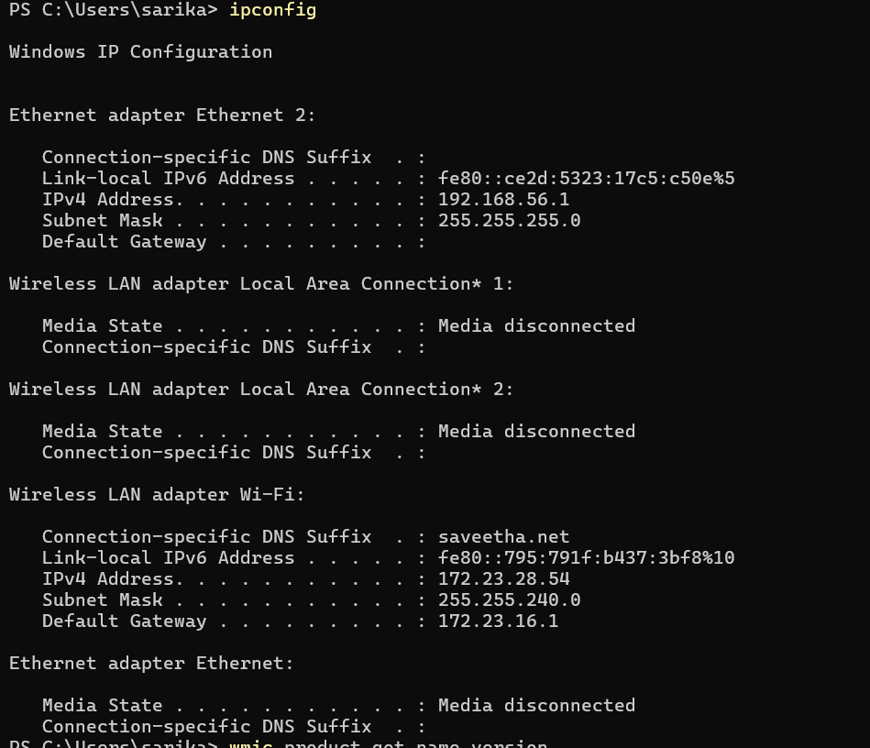
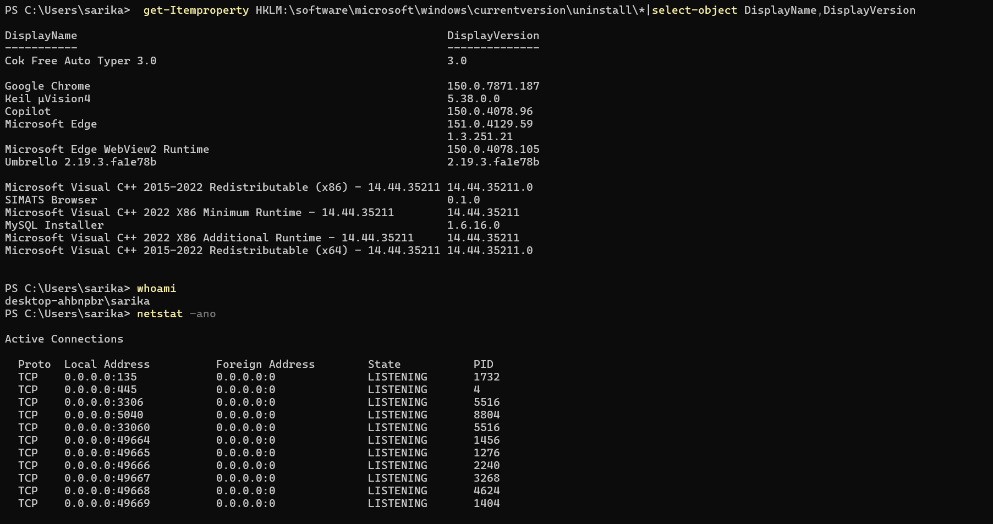
Conclusion:
Windows operating system enumeration helps administrators understand the system configuration, identify installed software, monitor services and network settings, troubleshoot issues, maintain inventory, and detect potential security risks in an authorized environment.

